**Exercise 2: Error Handling**

**Scenario 1:** Handle exceptions during fund transfers between accounts.

**Script Output:**

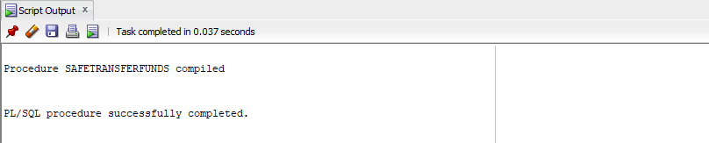

**DBMS Output:**

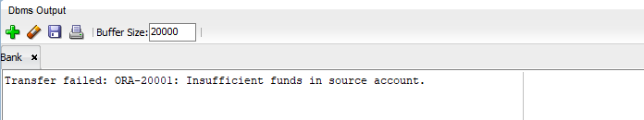

**Scenario 2:** Manage errors when updating employee salaries.

**Script Output:**

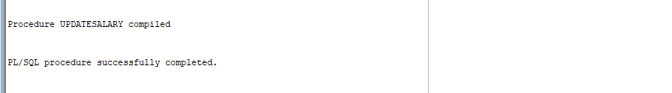

**DBMS Output:**



**Scenario 3:** Ensure data integrity when adding a new customer.

**Script Output:**

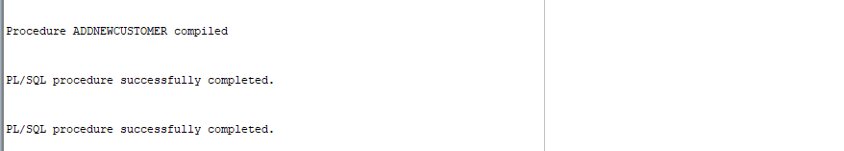

**Table Output:**

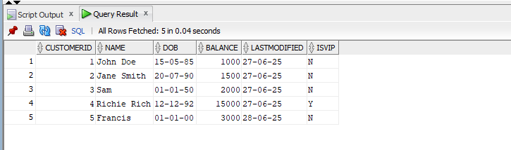

**DBMS Output:**

